## Activity 2

**Aim:** Create MongoDB database with the following Data types – String, Integer, Boolean, double, min/max keys, arrays, timestamp, object, Null, symbol, date, object ID, Binary data, Code, Regular Expression.

# **Learning outcome**: Able to configure embedded databases with different web pages using MongoDB.

###### Duration: 3 hours.

# List of Hardware/Software requirements:

* Laptop/Computer with windows
* XAMPP software PHP-7
* MongoDB

**Follow the below step’s**

1. Open the MongoDB Compass and click on Connect

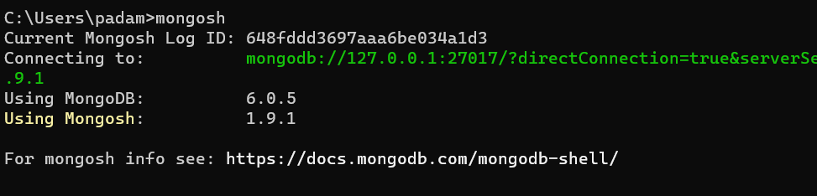

1. You get a default test database.

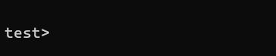

1. Type show dbs and hit enter you get all the information about all the databases.

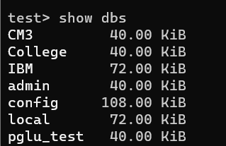

1. Type **use** **activity** (here we are creating a new database) and hit enter.
2. After this type db.stu.insertOne({name:'padam singh', salary:10000, course:'adit', persentagein12:64.59, pass:true}) this cmd use to insert record into the collection(stu is our collection).

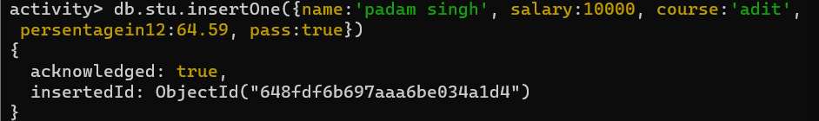

1. I am inserting some records.
2. After this type db.stu.find().pretty() and hit enter.

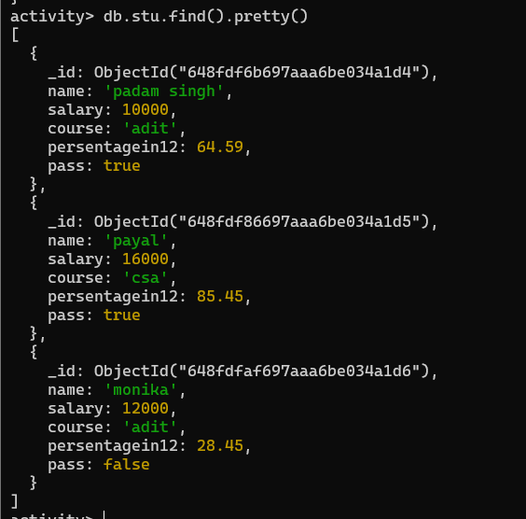

1. Here we are not able to see the data type for these records. Just open the mongodb compass and click on connect.

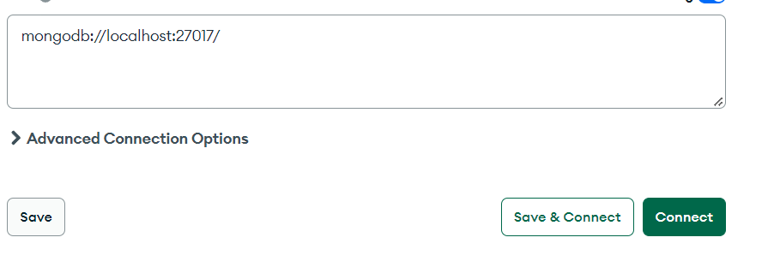

1. Go to the database which name is activity and click on stu collection in side of stu collection you can see all the fields.

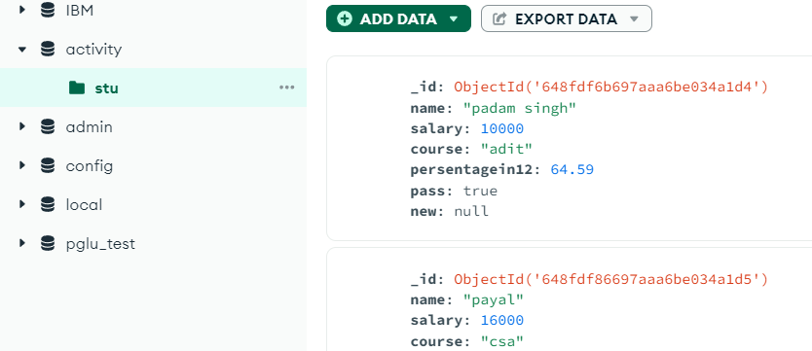

1. Go to the fields and click on edit field.

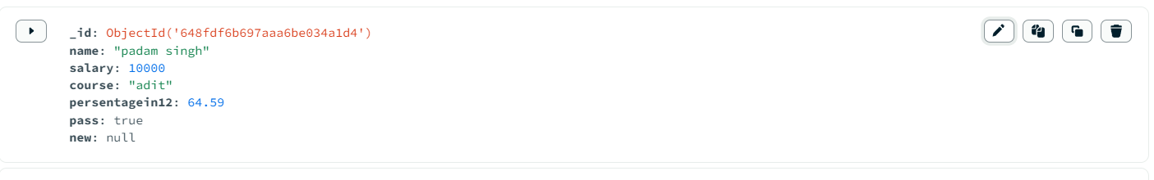

1. After tis you can see all the data type of this fields.

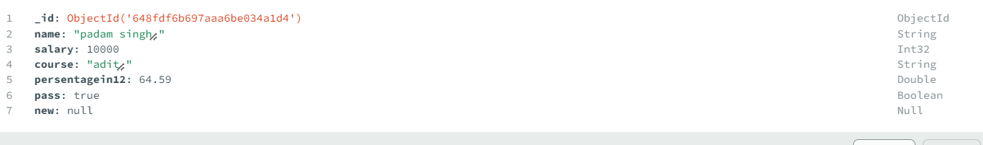

## Activity 3

Aim – Insert Document in database.

# Learning outcome: Able to configure embedded databases with different web pages using MongoDB.

###### Duration: 1 hour

# List of Hardware/Software requirements:

* Laptop/Computer with windows
* XAMPP software PHP-7
* MongoDB

**Follow the below step’s**

* Step -1 Open the CMD/windows PowerShell.
* Step -2 Know just type **mongosh** and enter. (Here mongodsh is use to show connection between the mongoDBCompass and see below image).

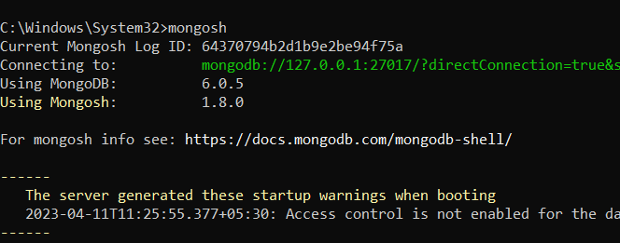

* Step -3 After the 2nd step just type the **show dbs** and enter. Here you can see all databases and they have a default database which name is test (Here show dbs is use to show the all-available databases and see below image).

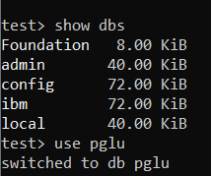

* Step -4 Type **use pglu** and enter (This CMD use for select database but upper image there don’t have any pglu database. That’s mean here we can use a new database which name is pglu but they don’t have any Documents (MySQL name -Rows) and Fields (MySQL name -Columns) let’s see the upper image and 5th step also).
* Step -5 Type **db.Emp.insertOne({name:”Payal”,salary:19000})** and enter. (This cmd use to insert only one value into the database).

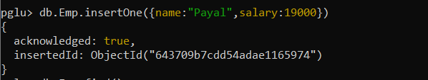

* Step -6 Type **db.Emp.find()** and enter (this cmd use to show collection and see below image).

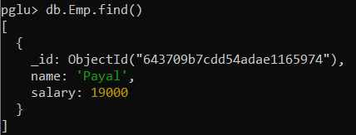

* Step -7 Type **db.Emp.insertMany([{name:"Payal",salary:19000},{name:"Priyanka",salary:25000},{}])** and enter (This cmd use to insert many values into the database see the below image).

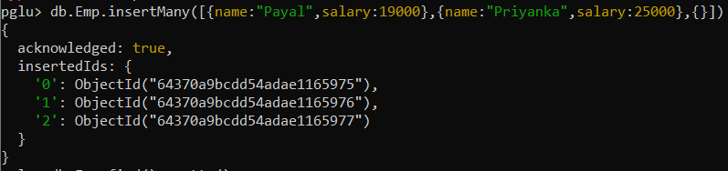

* Step -8 Type **db.Emp.find().pretty()** and enter (This cmd use to show collection same like step 6 cmd and see below image).

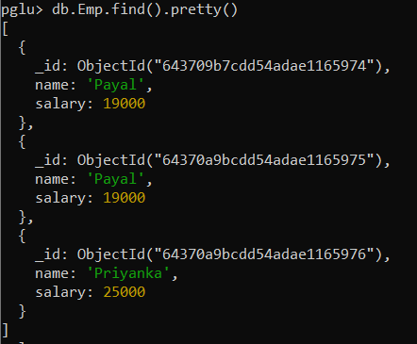

* Step -9 There we have completely insert some values. Let’s move to **mongoDBCompass** and click on connect (Remember that mongoDBCompass have a default local host no – 27017 see below image)

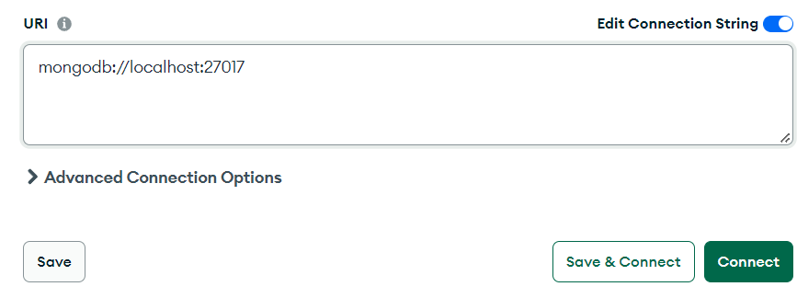

* Step -10 Let’s select **pglu** database see below image.

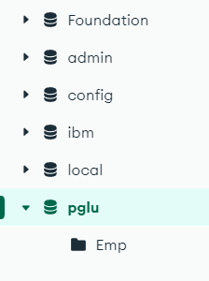

* Step -11 Know click on **Emp** collection (MY SQL name - Table) see below image.

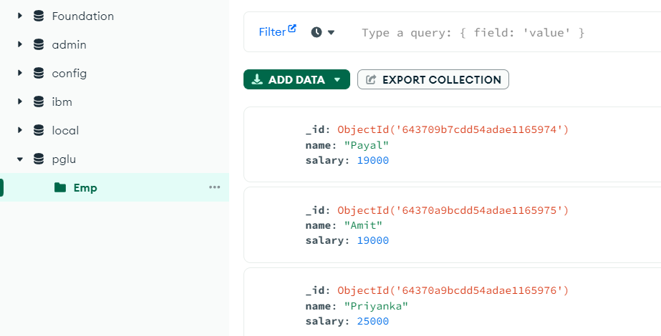

* Step -12 Click on **add data** and click on **insert documents** see below image.

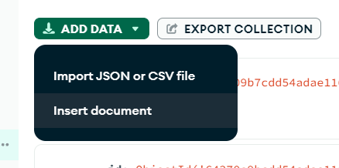

* Step -13 Then select GUI option see below image.

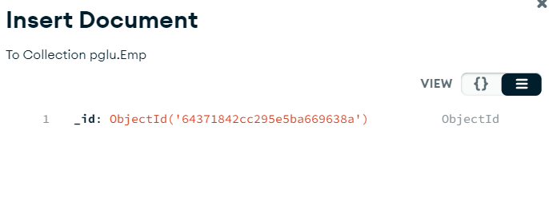

* Step -14 After 13th step click on this icon for insert the values and **add fields after _id** see below image.

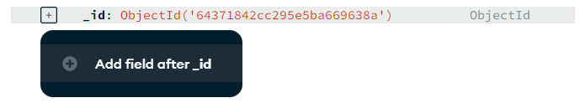

* Step -15 When you are complete 14th step then do what you want to do and here a dropdown which have all type of **data type** select with your condition and click on insert see below image.

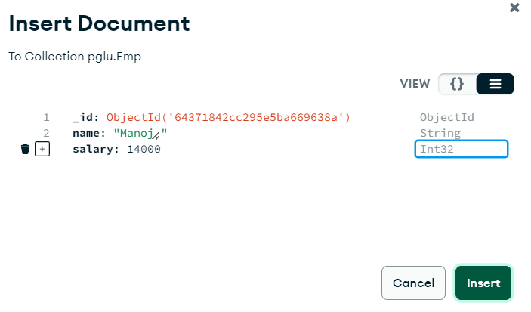

* Step -16 Then you can see you have successfully inserted a value into the **Emp** collection see below image.

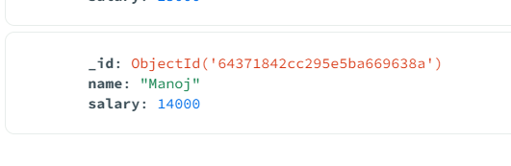

* Step -11 Let’s insert 6 more values into the emp collection.
* Step -12 We have successfully insert at least 10 values and type **db.Emp.find()** for show insert values see below image.

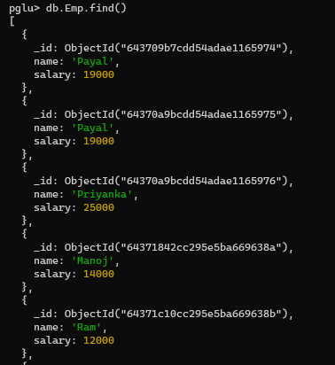 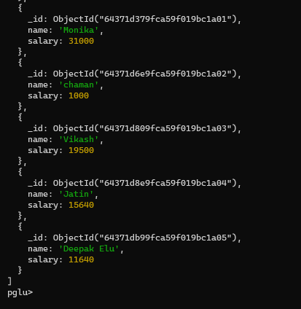

## Activity 4

Aim – Update Document in database.

# Learning outcome: Able to configure embedded databases with different web pages using MongoDB.

###### Duration: 1 hour

# List of Hardware/Software requirements:

* Laptop/Computer with windows
* XAMPP software PHP-7
* MongoDB

**Follow the below step’s**

Step 1: **use pglu** (This is use for choose database which you want to insert values.

Step 2: db.Emp.InsertOne({name:”Anita”, salary: 15000}). (This cmd is to insert a value into the collection and here is Emp is Collection)

**Output:**

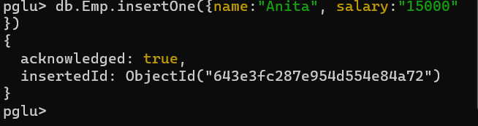

**Update cmd**

Step 3: db.Emp.updateOne({name:”Anita”}, {$set:{name:”Moto”}})

**Input:**

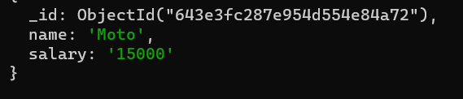

## Activity 5

Aim – Delete Document in database.

# Learning outcome: Able to configure embedded databases with different web pages using MongoDB.

###### Duration: 1 hour

# List of Hardware/Software requirements:

* Laptop/Computer with windows
* XAMPP software PHP-7
* MongoDB

**Follow the below step’s**

Step 1: **use pglu** (This is use for choose database which you want to insert values.

Step 2: db.Emp.InsertOne({name:”Anita”, salary: 15000}). (This cmd is to insert a value into the collection and here is Emp is Collection)

**Output:**



**Delete cmd**

* **deleteOne**

Step 3: db.Emp.deleteone({name:”Deepak elu”}) (This cmd is use for delete fields. There have to type pf delete deleteOne and deleteMany. If you want to delete Many fields then ypou can go with deleteMany)

**Input:**

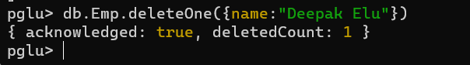

* **deleteMany**

Step 4: **db.Emp.insertMany([{name:"Aarti",salary:15000},{name:"Aarti",salary:15000},{}])** and enter (This cmd use to insert many values into the database see the below image).

**Input:**

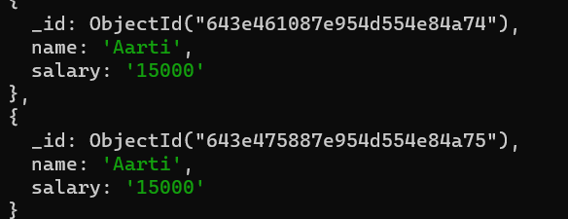

Step 5: db.Emp.deleteMany({name:"Aarti"})

**Output:**

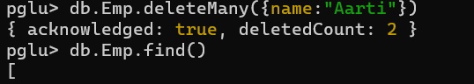

## Activity 6

Aim – Project Document in database.

# Learning outcome: Able to configure embedded databases with different web pages using MongoDB.

###### Duration: 2 hours

# List of Hardware/Software requirements:

* Laptop/Computer with windows
* XAMPP software PHP-7
* MongoDB

**Follow the below step’s**

Step -1 Open cmd then type mongosh. After it create a database which name is adit.

Type **use adit** is cmd is use to create a new database without any value.

Step -2 We insert at lest 10 value into **adit**. Use this cmd for inserting any document into the collection. **db.stu.insertOne({Id:1,Name:"payal",Lab:"php",CertificateNo:11, Course:"ibm", StartDate:2018,EndDate:2020})**.

Output:

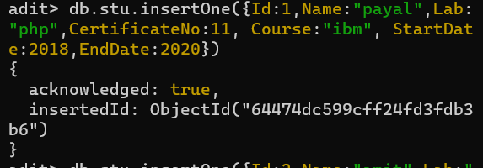

Step -3 Project document in database type **db.stu.find()** (this cmd is use to show all document)

Output:

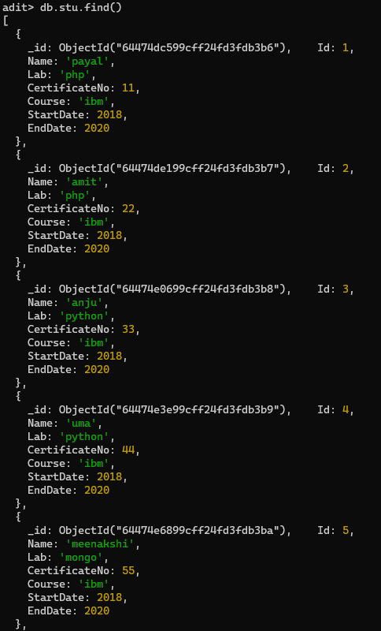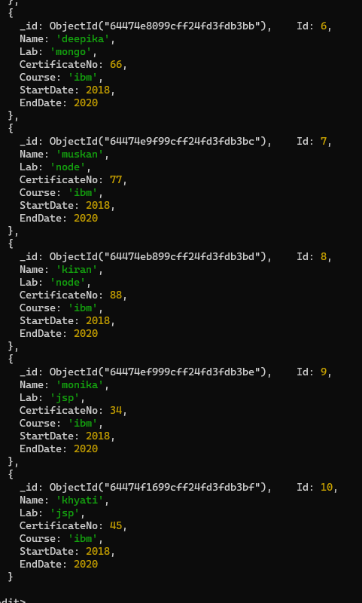

## Activity 7

Aim – Create a MongoDB query to display all the documents in the collection data (Trainees data)

# Learning outcome: Able to configure embedded databases with different web pages using MongoDB.

###### Duration: 5 hours

# List of Hardware/Software requirements:

* Laptop/Computer with windows
* XAMPP software PHP-7
* MongoDB

**Follow the below step’s**

Step -1 Open cmd then type mongosh. After it create a database which name is adit.

Type **use adit** is cmd is use to create a new database without any value.

Step -2 We insert at least 10 values into **adit**. Use this cmd for inserting any document into the collection. **db.stu.insertOne({Id:1,Name:"payal",Lab:"php",CertificateNo:11, Course:"ibm", StartDate:2018,EndDate:2020})**.

Output:



Step -3 Project document in database type **db.stu.find().pretty()** (this cmd is use to show all document)

Output:

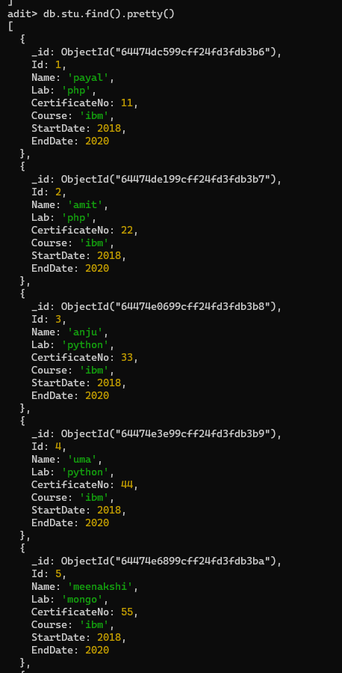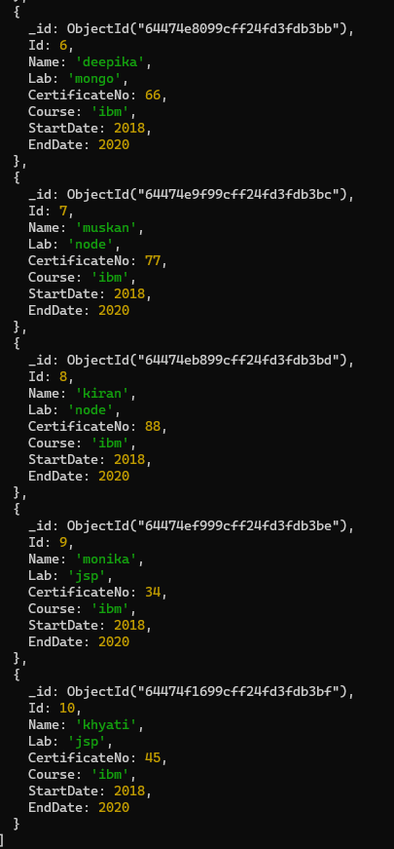

## Activity 8

Aim – Create a MongoDB query to display the fields id, trainee name, lab name, Certificate No., course title, course starting date,course ending date for all the documents in the collection trainees data.

# Learning outcome: Able to configure embedded databases with different web pages using MongoDB.

###### Duration: 5 hours

# List of Hardware/Software requirements:

* Laptop/Computer with windows
* XAMPP software PHP-7
* MongoDB

**Follow the below step’s**

1. Open the mongodb compass and click on connect (Remember that mongoDBCompass have a default local host no – 27017 see below image)



1. Go to the activity database and create a new collection which name is **tra** and click on create Collection.

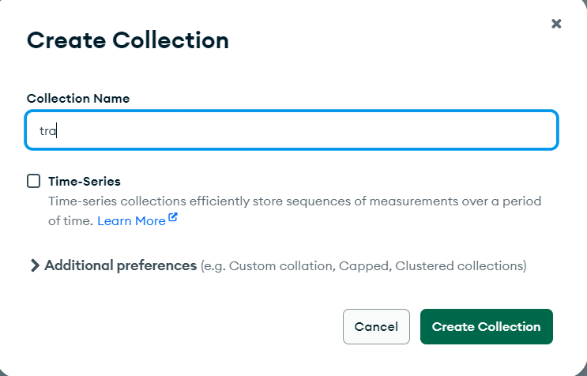

1. Click on add data then click on import json or csv file and select the csv file into the pc and click on import. After this you can see all data insert into the collection.

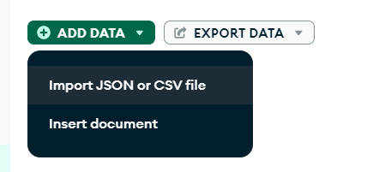

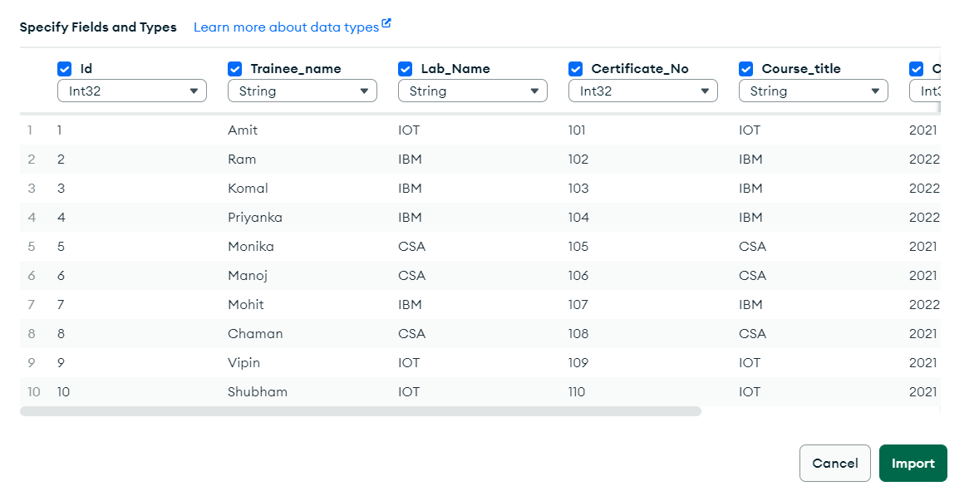

1. Go cmd and type mongosh, show dbs and after this type use activity.

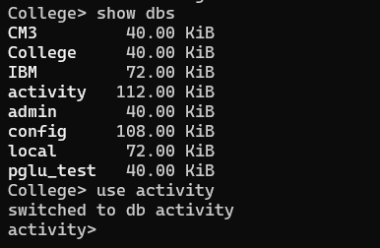

1. Our collection name is tra. Type db.tra.find().pretty()

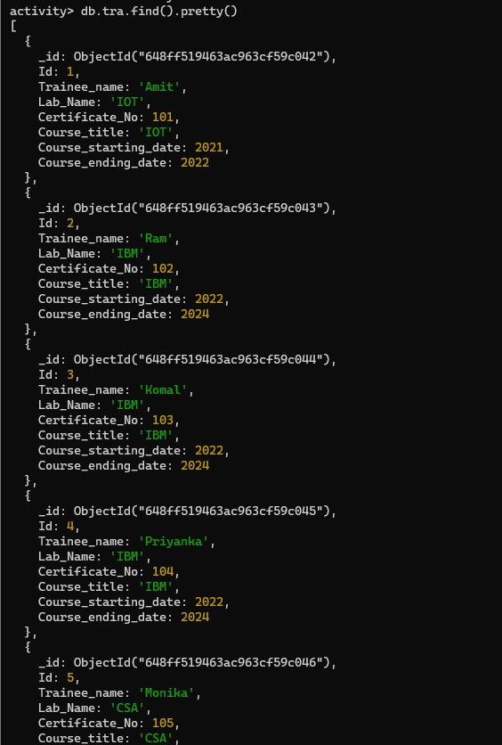

## Activity 9

Aim – Create a MongoDB query to display the fields id, trainee name, lab name, Certificate No., course name, course starting date, the course ending date for all the documents in the collection trainee’s data, but excluding lab name

# Learning outcome: Able to configure embedded databases with different web pages using MongoDB.

###### Duration: 5 hours

# List of Hardware/Software requirements:

* Laptop/Computer with windows
* XAMPP software PHP-7
* MongoDB

**Follow the below step’s**

1. Go cmd and type mongosh, show dbs and after this type use activity.



1. Type db.tra.find({}, {Lab_Name:0}).pretty() and hit enter. You get all record’s but lab name not mention into the records.

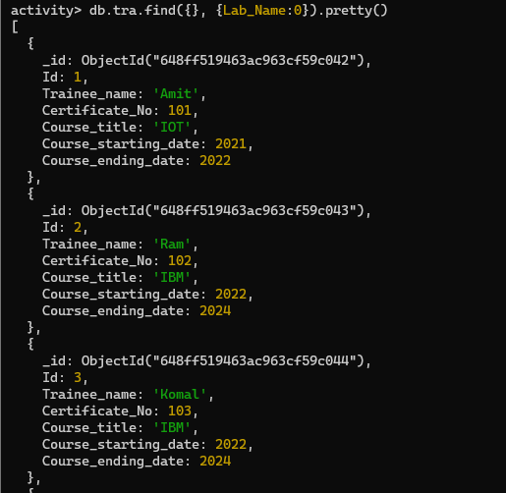

## Activity 10

Aim – Create a MongoDB query to display all the trainees who attended courses on IBM.

# Learning outcome: Able to configure embedded databases with different web pages using MongoDB.

###### Duration: 2 hours

# List of Hardware/Software requirements:

* Laptop/Computer with windows
* XAMPP software PHP-7
* MongoDB

**Follow the below step’s**

1. Go cmd and type mongosh, show dbs and after this type use activity.



1. Type db.tra.find({Course_title:{$eq:'IBM'}}) and hit enter.

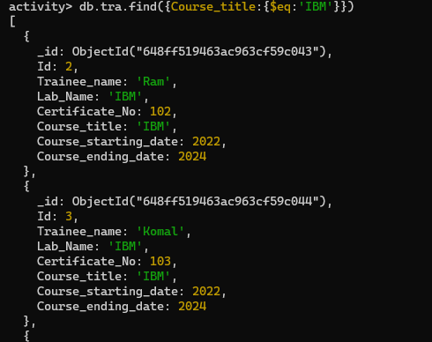

## Activity 11

Aim – Create a MongoDB query to display the 1st batch trainees of IOT.

# Learning outcome: Able to configure embedded databases with different web pages using MongoDB.

###### Duration: 2 hours

# List of Hardware/Software requirements:

* Laptop/Computer with windows
* XAMPP software PHP-7
* MongoDB

**Follow the below step’s**

1. Go cmd and type mongosh, show dbs and after this type use activity.



1. Type db.tra.find({Course_starting_date:{$eq:2021}}) and hit enter.

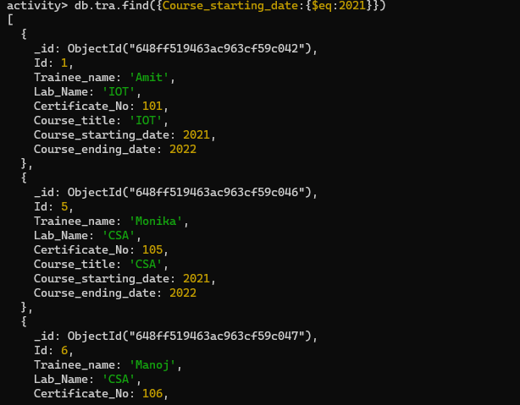

## Activity 12

Aim – Create a MongoDB query to display the 2nd batch trainees of IBM.

# Learning outcome: Able to configure embedded databases with different web pages using MongoDB.

###### Duration: 2 hours

# List of Hardware/Software requirements:

* Laptop/Computer with windows
* XAMPP software PHP-7
* MongoDB

**Follow the below step’s**

1. Go cmd and type mongosh, show dbs and after this type use activity.



1. Type db.tra.find({Course_starting_date:{$eq:2022}}) and hit enter.

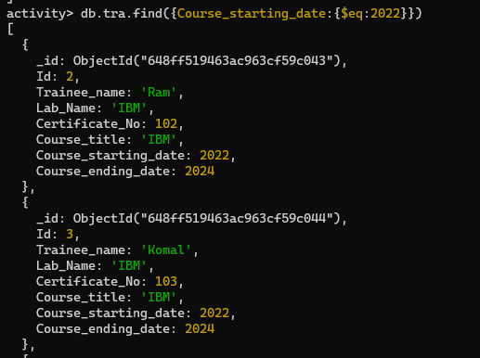

## Activity 13

Aim – Create a MongoDB query to find the course where maximum trainees attended.

# Learning outcome: Able to configure embedded databases with different web pages using MongoDB.

###### Duration: 2 hours

# List of Hardware/Software requirements:

* Laptop/Computer with windows
* XAMPP software PHP-7
* MongoDB

**Follow the below step’s**

1. Go cmd and type mongosh, show dbs and after this type use activity.



1. Type db.tra.aggregate([{$project:{maximum_courses:{$max:"$Lab_Name"}}}]).pretty().

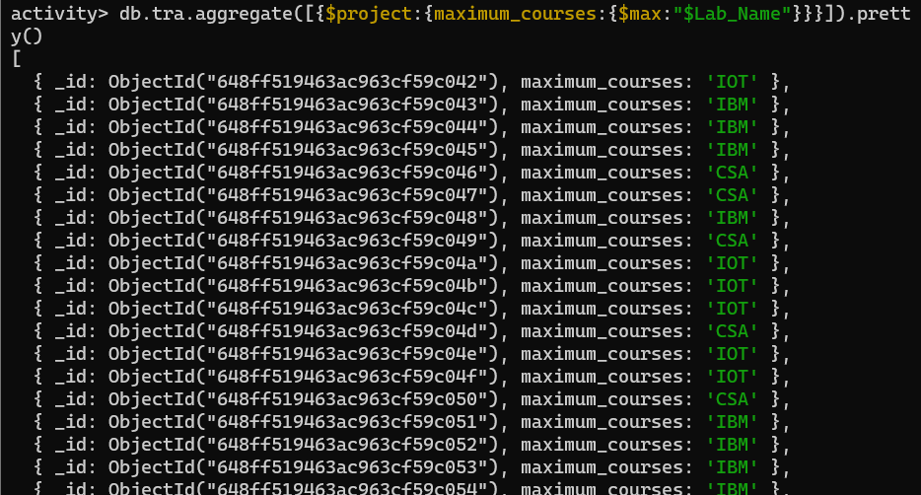

## Activity 14

Aim – Create a MongoDB query to find lab wise details of trainees.

# Learning outcome: Able to configure embedded databases with different web pages using MongoDB.

###### Duration: 2 hours

# List of Hardware/Software requirements:

* Laptop/Computer with windows
* XAMPP software PHP-7
* MongoDB

**Follow the below step’s**

1. Go cmd and type mongosh, show dbs and after this type use activity.



1. Type db.tra.find().pretty() and hit enter.

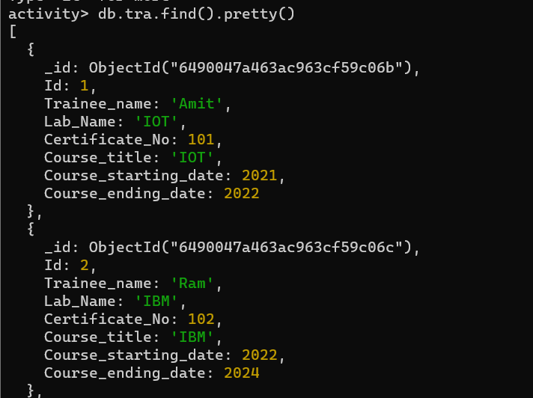

## Activity 15

Aim – Create a MongoDB query to find Course wise details of trainees.

# Learning outcome: Able to configure embedded databases with different web pages using MongoDB.

###### Duration: 2 hours

# List of Hardware/Software requirements:

* Laptop/Computer with windows
* XAMPP software PHP-7
* MongoDB

**Follow the below step’s**

1. Go cmd and type mongosh, show dbs and after this type use activity.



1. Type db.tra.find().pretty() and hit enter.



## Activity 16

Aim – Create MongoDB cluster in MongoDB Atlas cloud service.

# Learning outcome: Able to configure embedded databases with different web pages using MongoDB.

###### Duration: 2 hours

# List of Hardware/Software requirements:

* Laptop/Computer with windows
* XAMPP software PHP-7
* MongoDB

**Follow the below step’s**

1. Open the mongodb compass and click on the CERATE FREE CLUSTER.

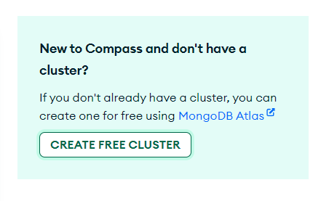

1. Click on Start free and login with your information.

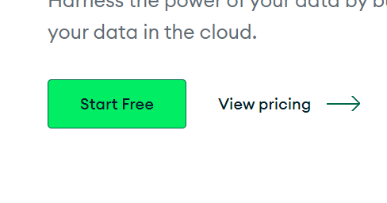

1. Go to The Database Access and click on add new Database User.

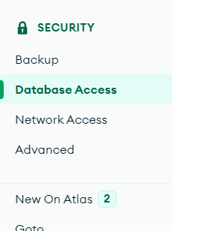 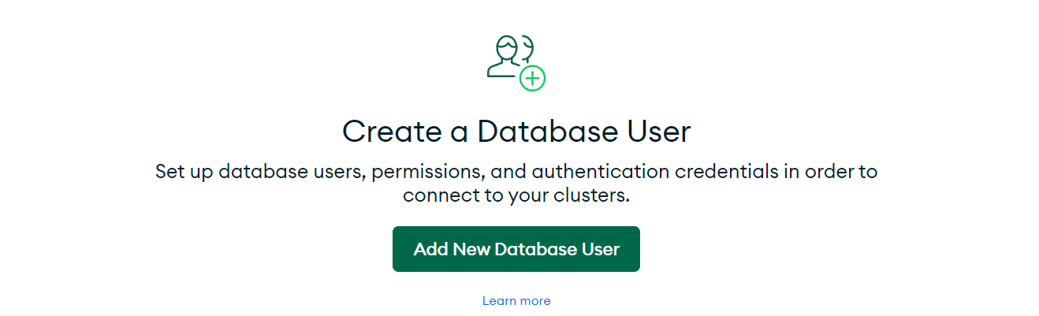

1. Select Authentication method and give the user name, password and click on the add user.

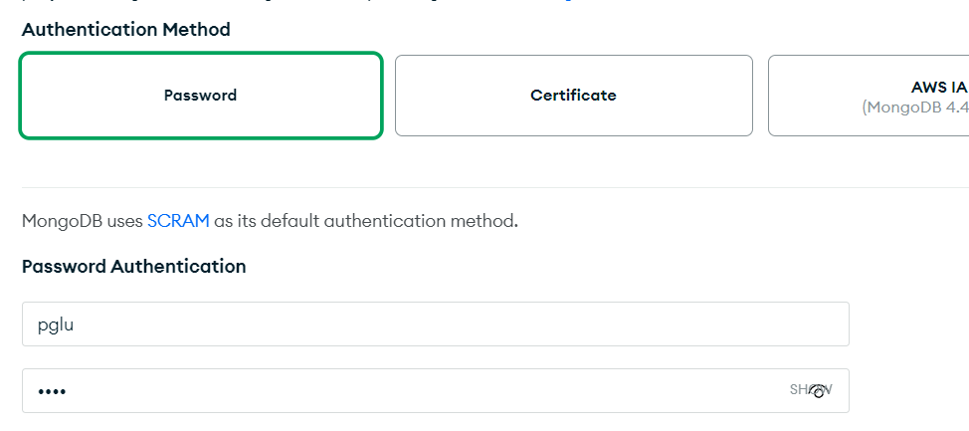

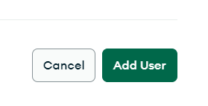

1. After the 4th step you get this output.



1. Go to the database and build a database.

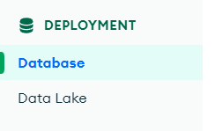 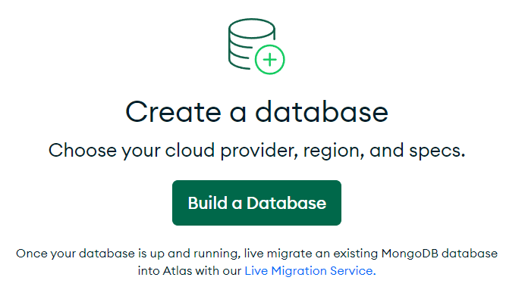

1. Select free service, select provider aws, region Mumbai and click on cretae.

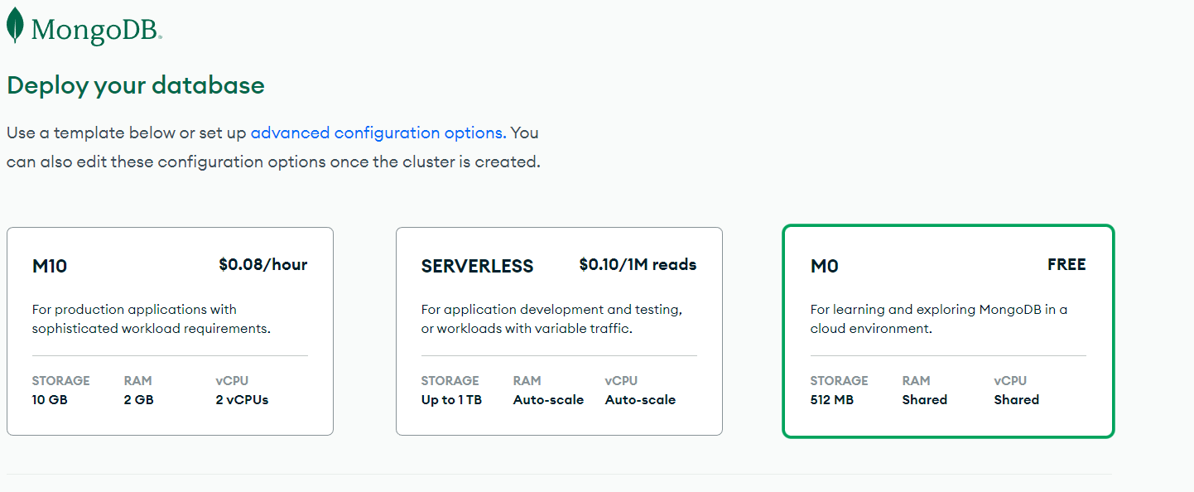

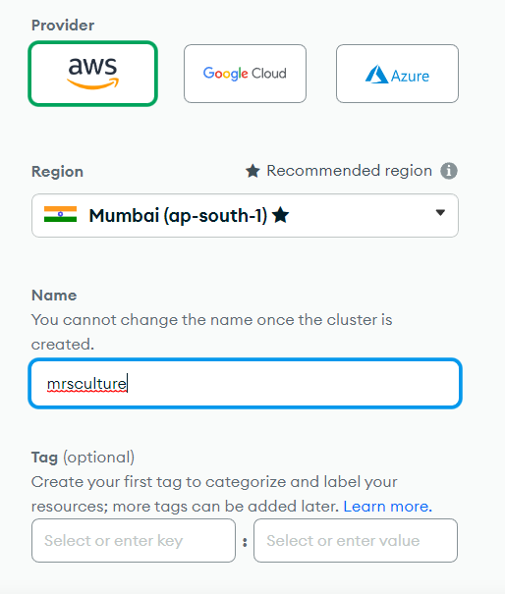 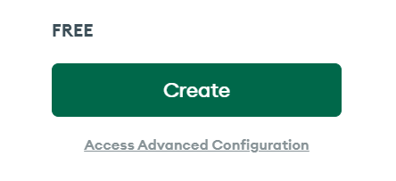

1. After 7th step you are redirect to Data service smiply click on finesh and close.

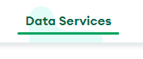 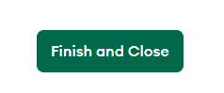

1. Click on connect.

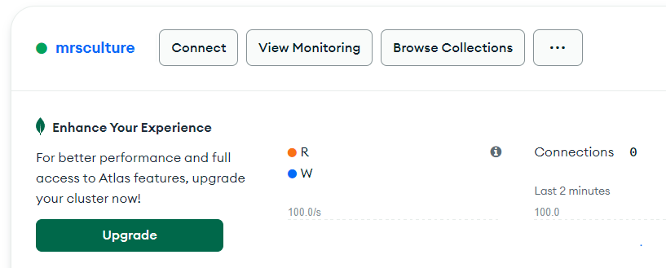

1. Select shell.

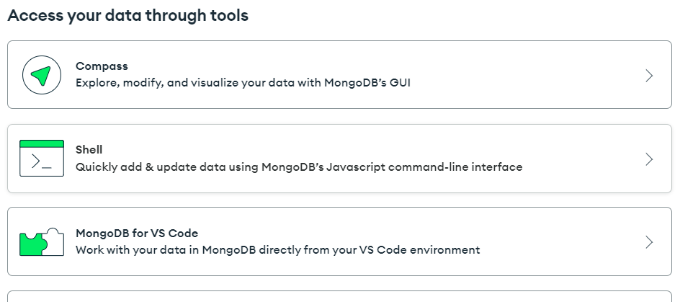

1. Select I have the mongodb shell installed and copy the below cmd.

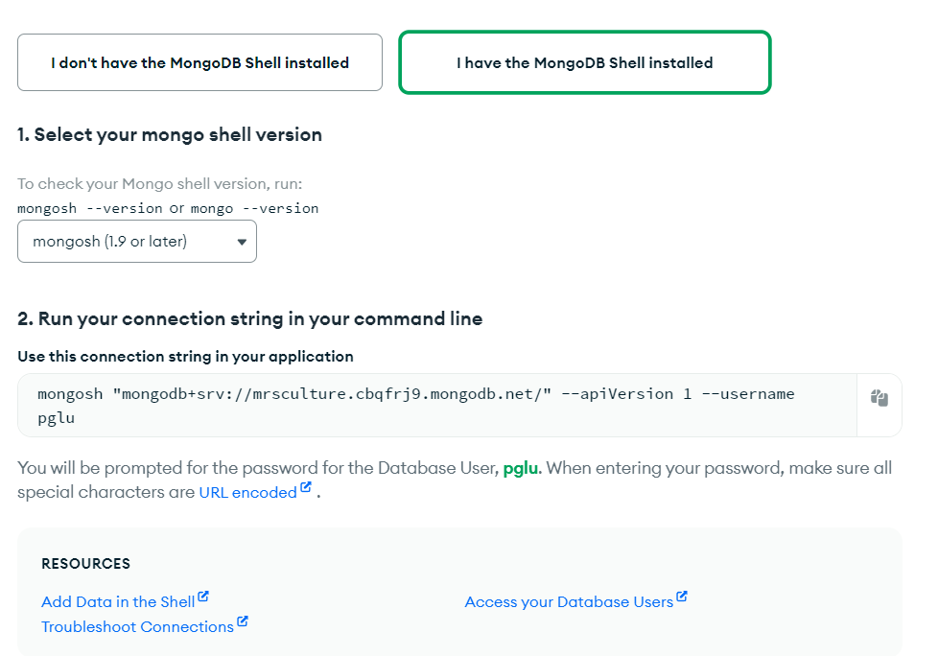

1. Go to the windows search and type cmd and paste the copy cmd and give the your user password.



1. If you get this type of window that’s mean you are connect successfully.

